**Industrial Internship at Elite Tech Intern.**

This document contains output screenshots of JOIN operations performed in MySQL for Task 1 of the Elite Tech Intern SQL Internship.

**Task 1- Joins Practice**

* Outputs:

1. Inner Join:

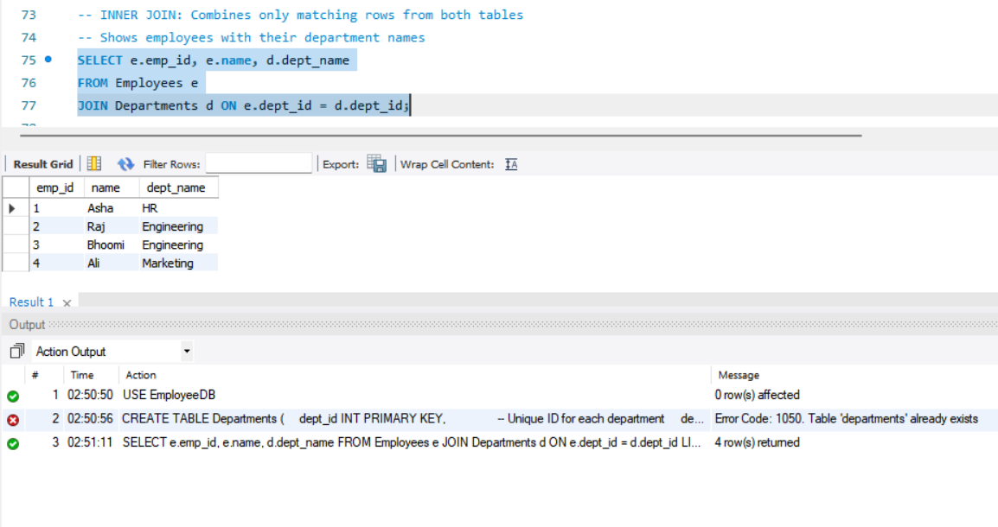

1. Left Join:

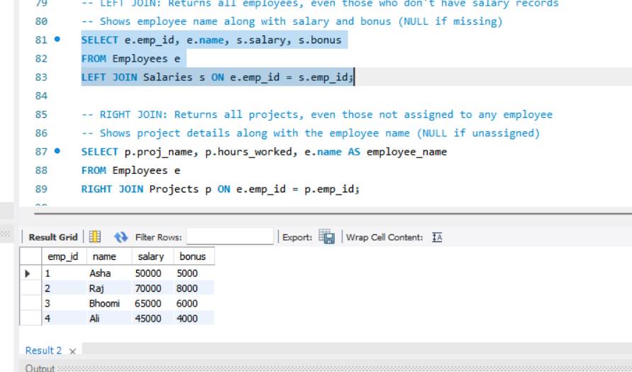

1. Right Join:

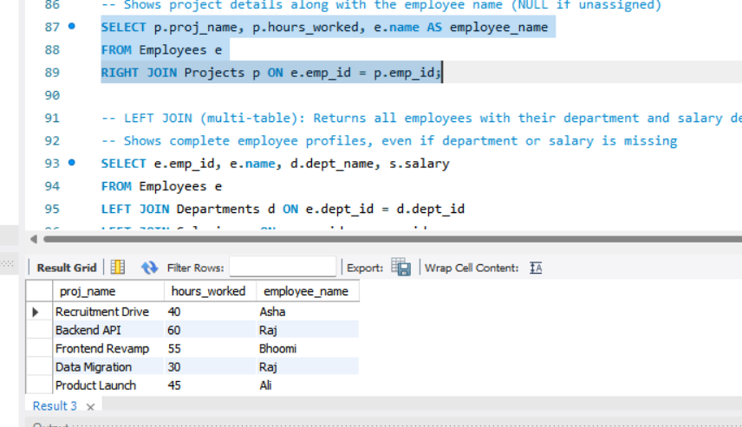

1. Left Join ( multi-table ):

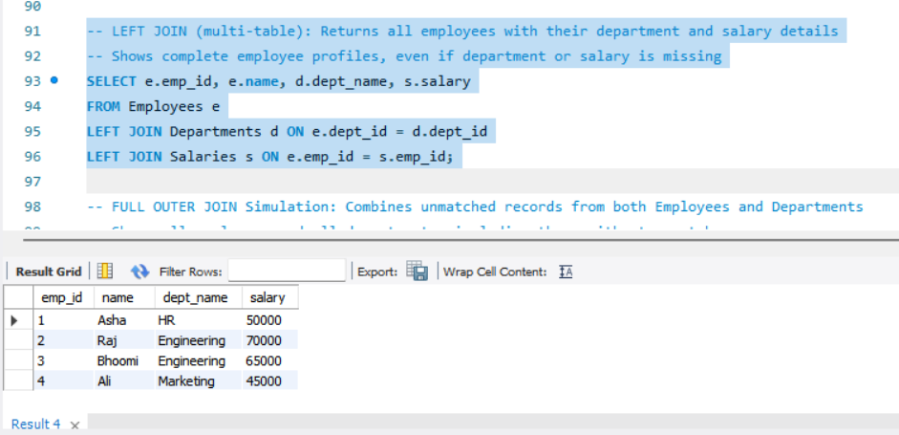

1. Full Join:

MySQL does not support FULL OUTER JOIN directly. To achieve similar results, I used a combination of LEFT JOIN and RIGHT JOIN with UNION.

